Jason Mejia 7/21/20

CSC336 Project 2

**CitiBike**

**Problem**:

In this project we are working with a more larger database than the other projects. In this database it contains information on the Citibike station location and about the user type for the bikes. Then we are required to create an E-R diagram for the table and for entity sets that will created for the project. Next, SQL expressions are needed to fill in required tables. These are Stations, Trips, UsageByDay, UasageByGender, and UsageByAge. Then create SQL expressions to determine the most frequent trips between any two stations by the day of the week. Lastly, we are going to create SQL expressions to find permanently dormant or vacant stations.

**Solutions:**

We are going to be using MySQL for this project. First the table needs to be imported into MySQL workbench. From our E-R diagram we have constructed SQL expression in MySQL workbench. Creating a table called bike_data needs to be created for the imported data to be stored. Then creating the other required tables such as Stations, Trips, UsageByDay, UasageByGender, and UsageByAge by using the information from table bike_data. The table stations will contain the ID, name and the location of Citibike stations and it will use the data from the table bike_data. The next table to be created is trips and it will contain a foreign key that references stationsID from the table stations. It also contains the min, max, avg trips from each station and types of user. The listed information will be taken from the table bike_data. In the table UsageByDay it will also reference stationsID from the table stations. Also containing the different types of users depending on the day of the week. This continues for the rest of the tables, they each reference stationsID from the table stations and receive the rest of their information from the first table bike_data. For frequent trips of the project, I used the information from the original table bike_data, seeing the start and end station names. For the last part, a similar query is used for finding the vacant stations.

**E-R Diagram**

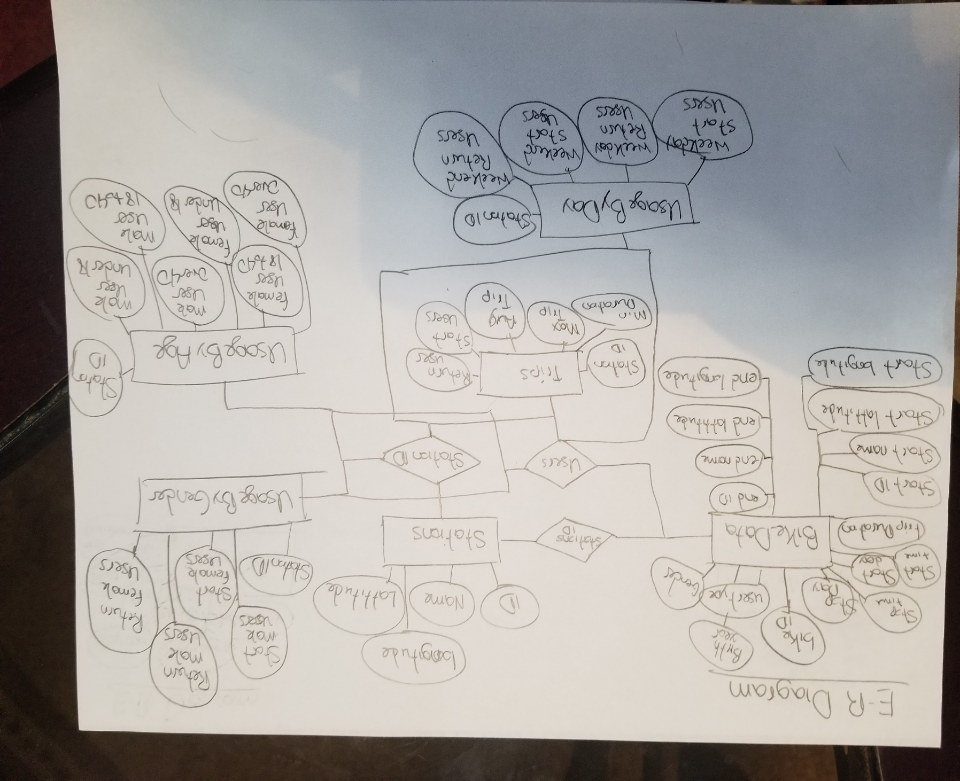

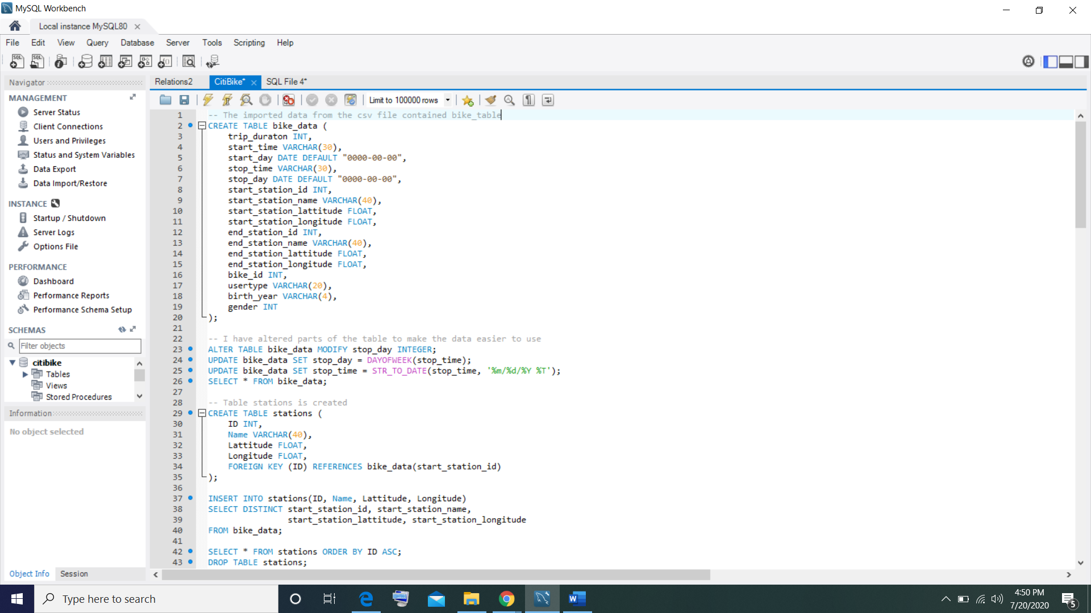**Code: CitiBike.sql**

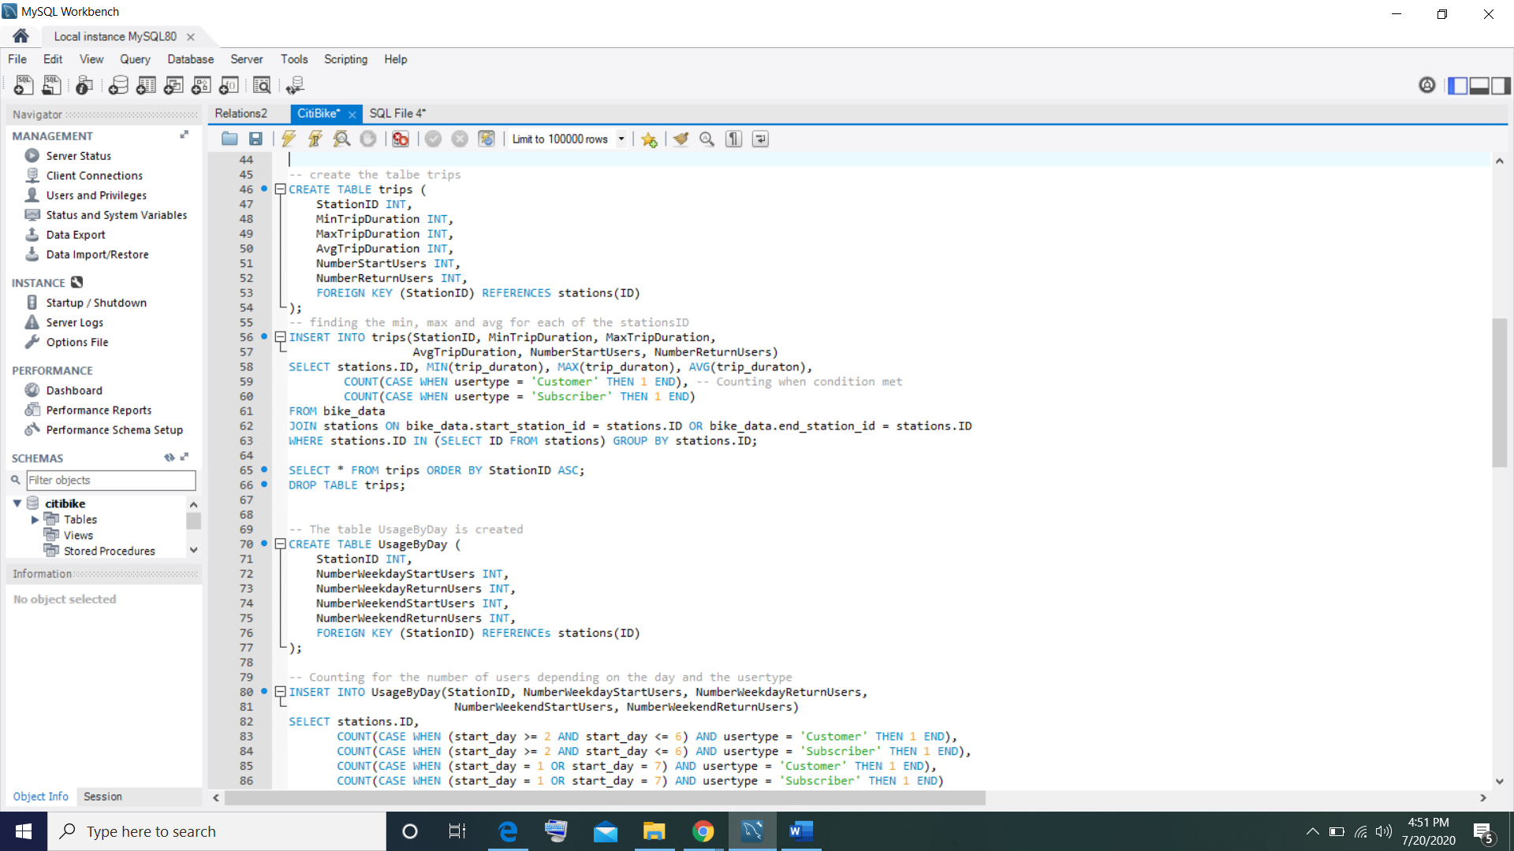

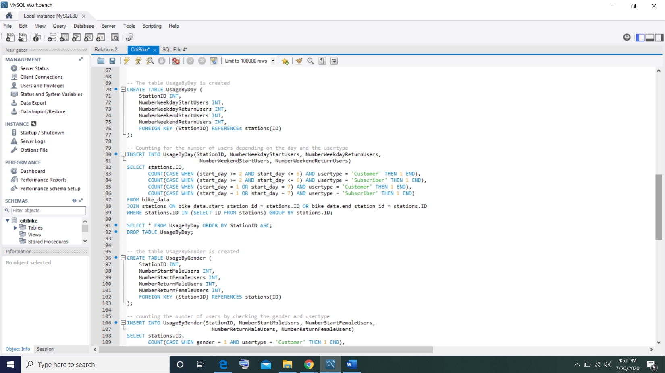

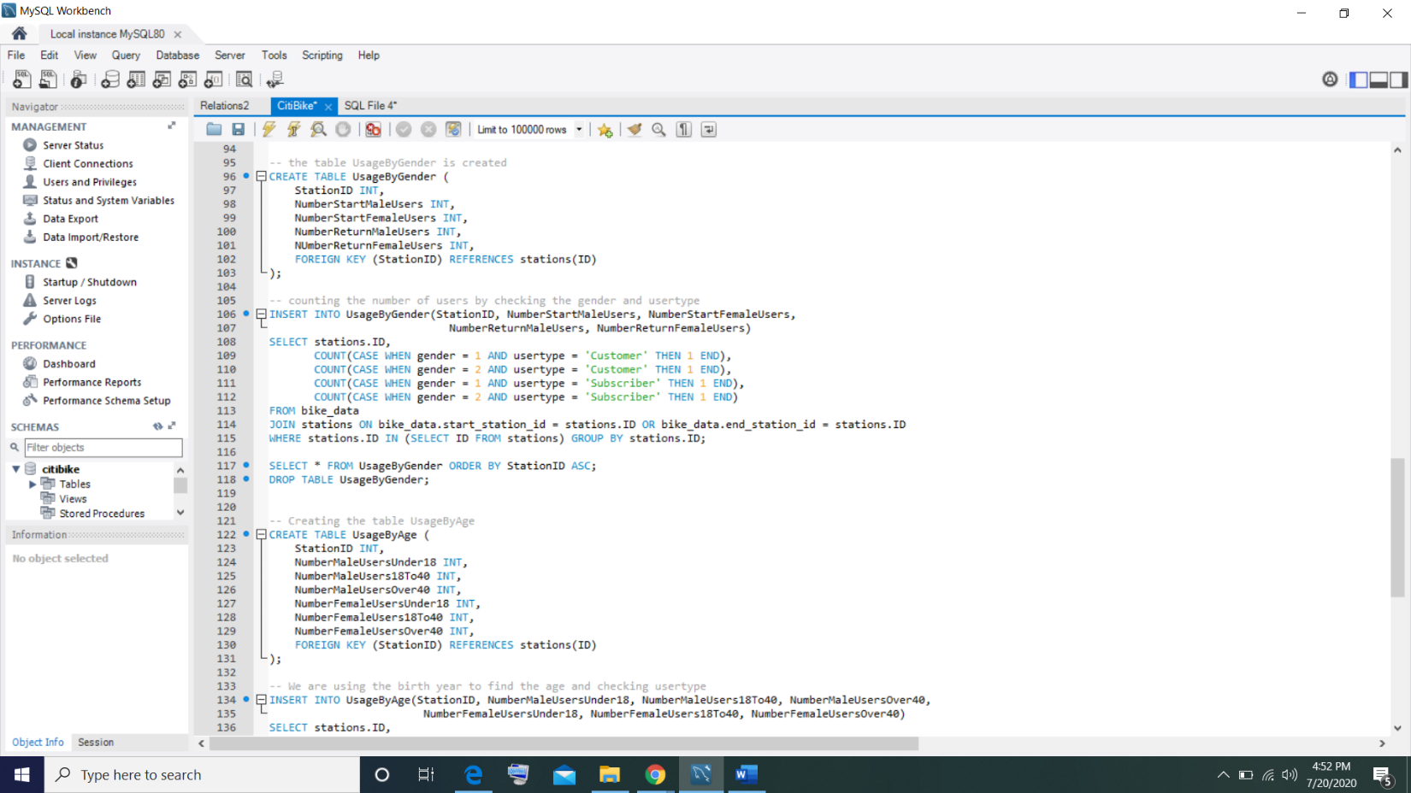

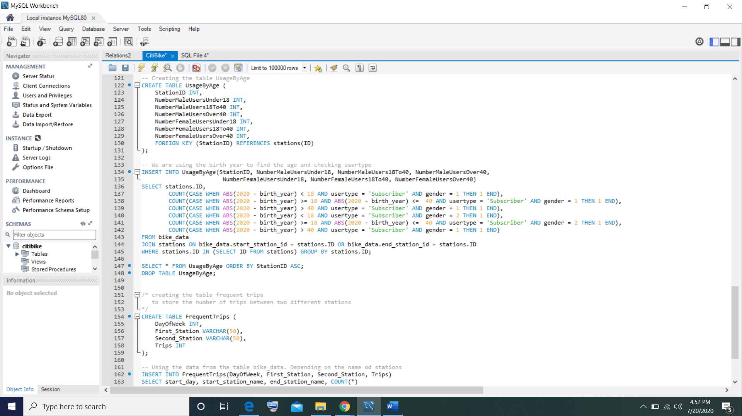

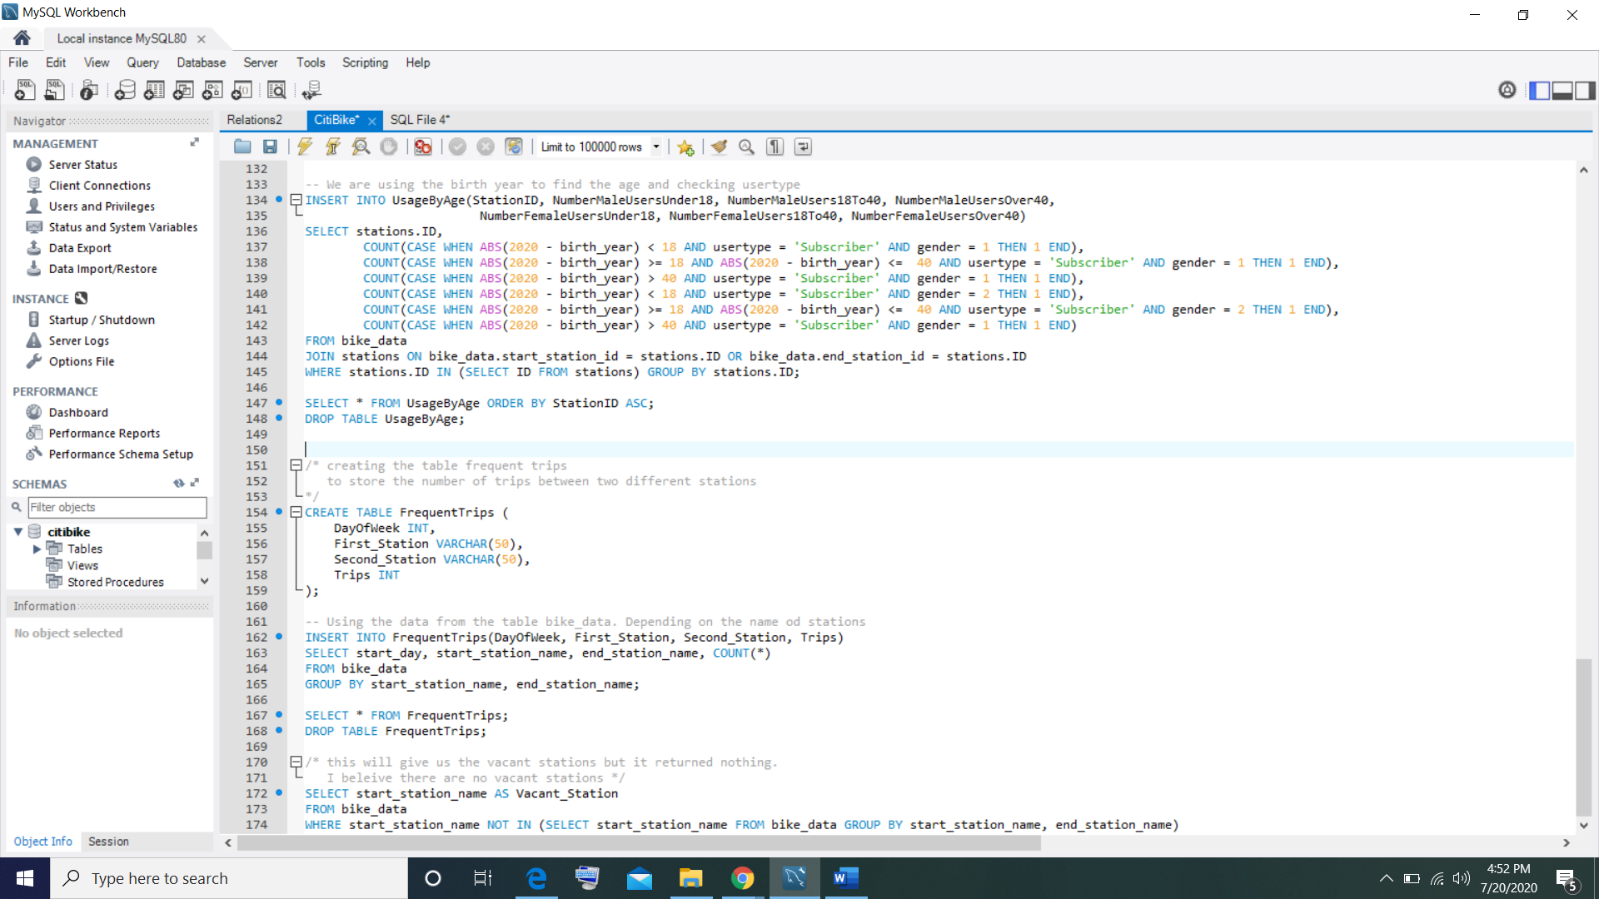

**Output:**

**Table – bike_data**

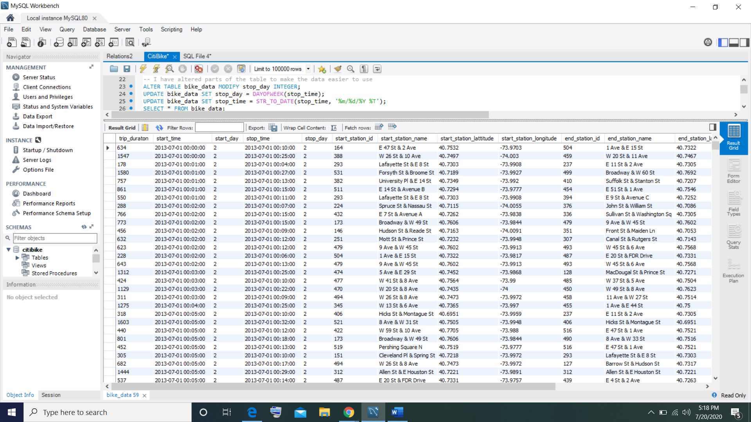

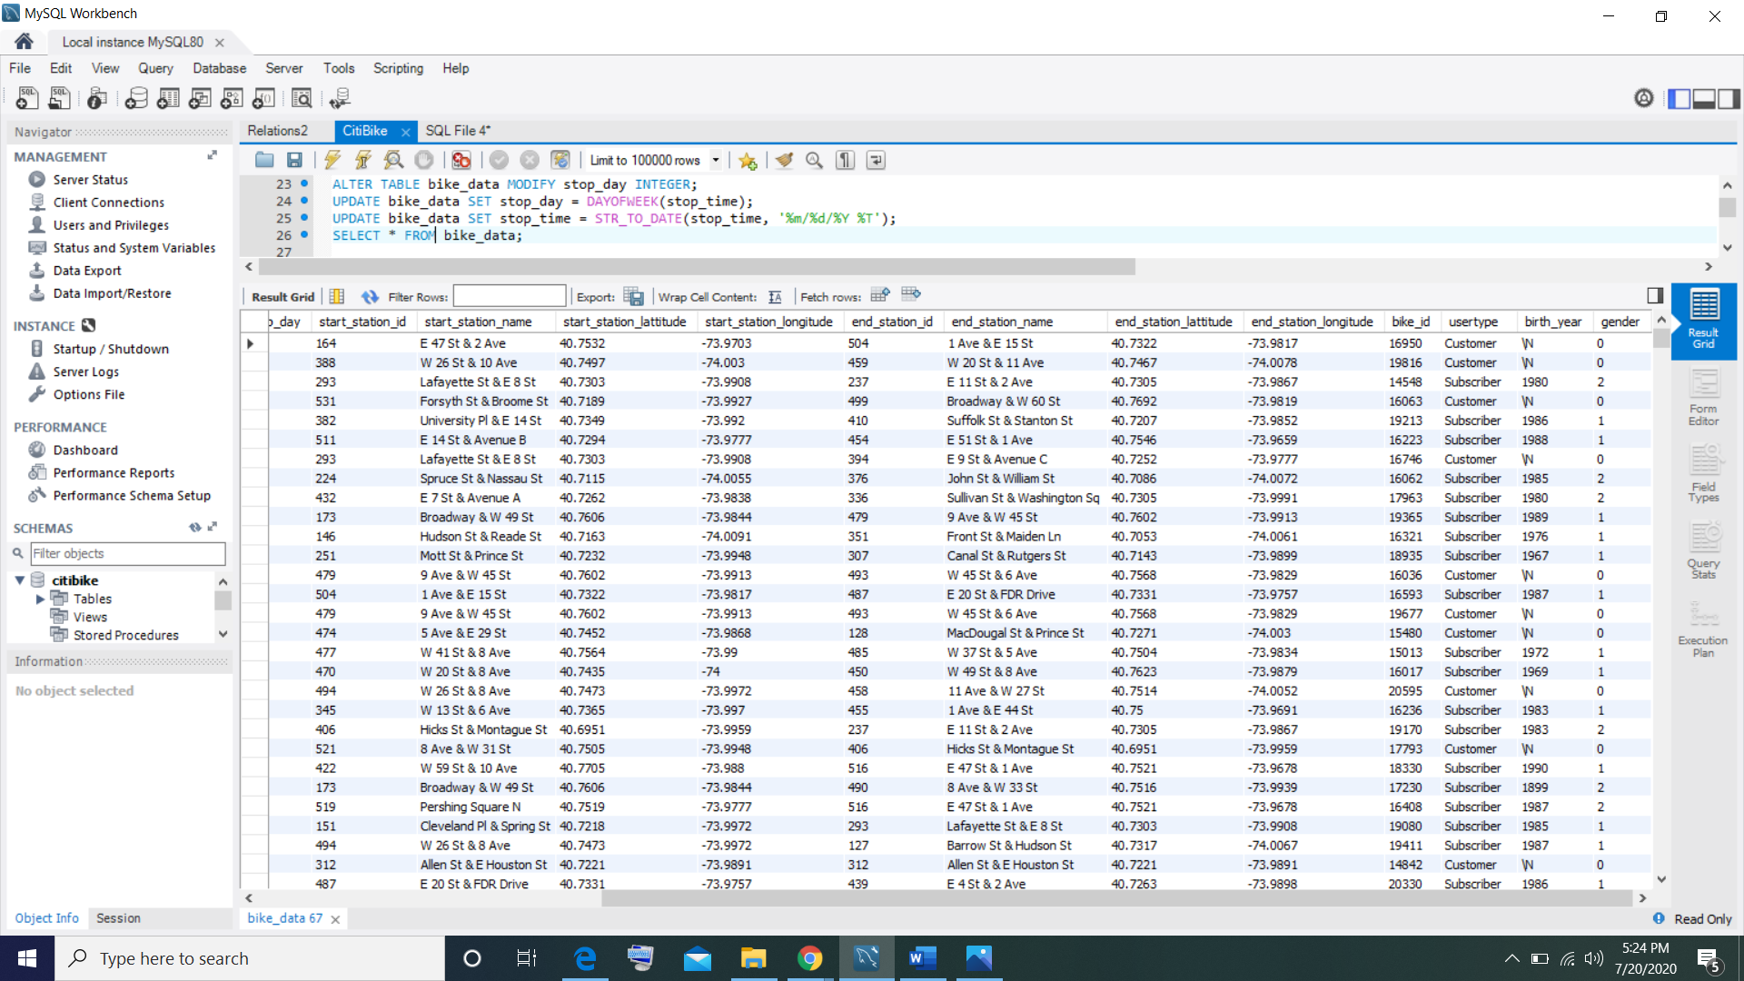

**Table – Stations**

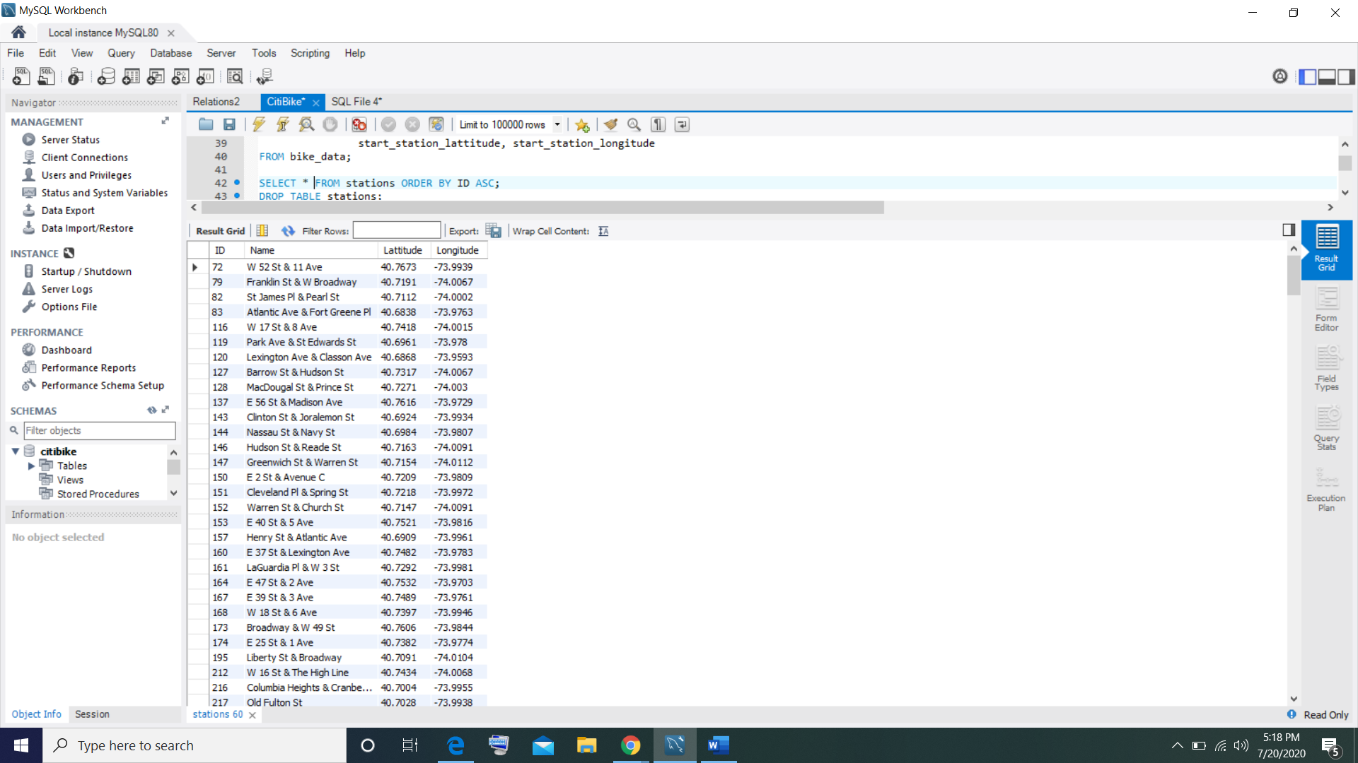

**Table – Trips**

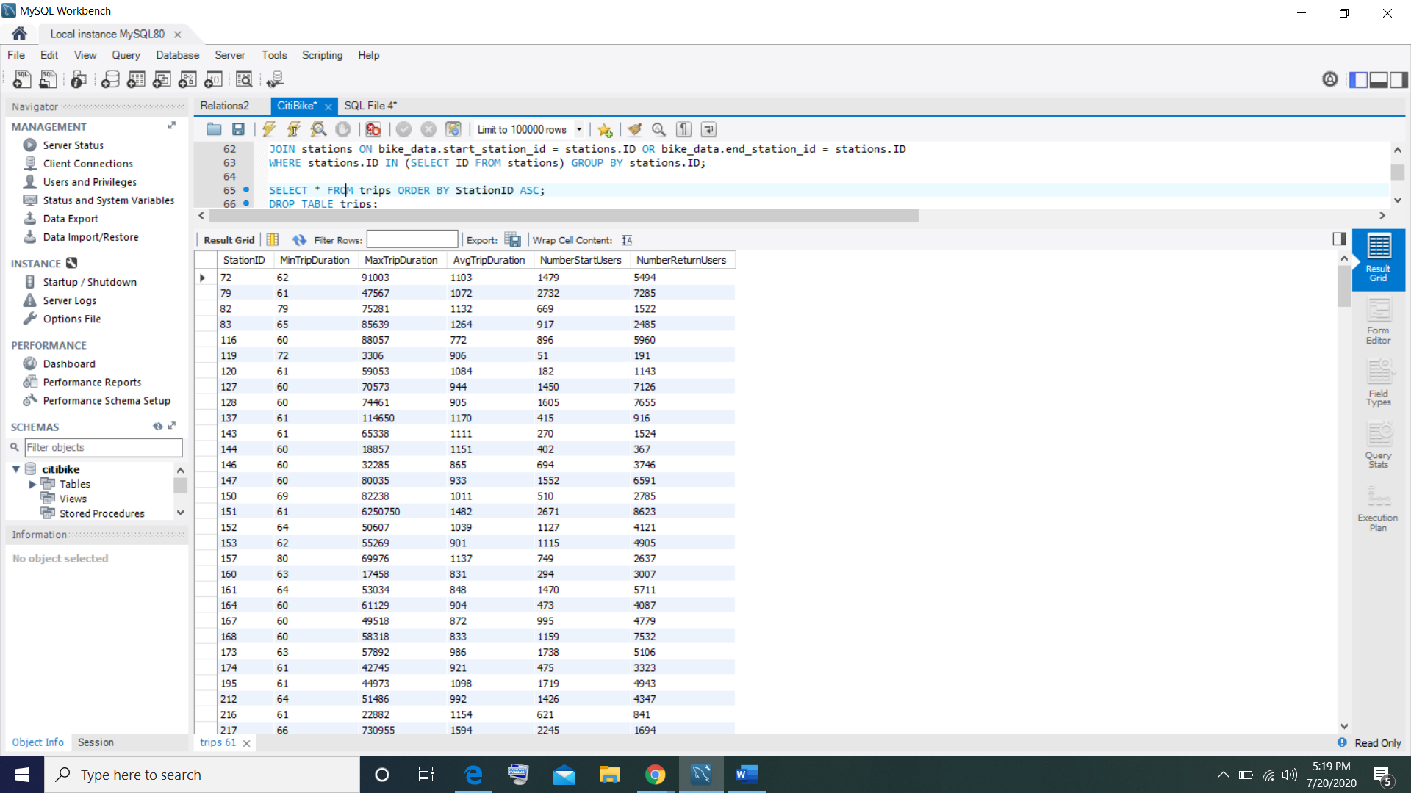

**Table – UsageByDay**

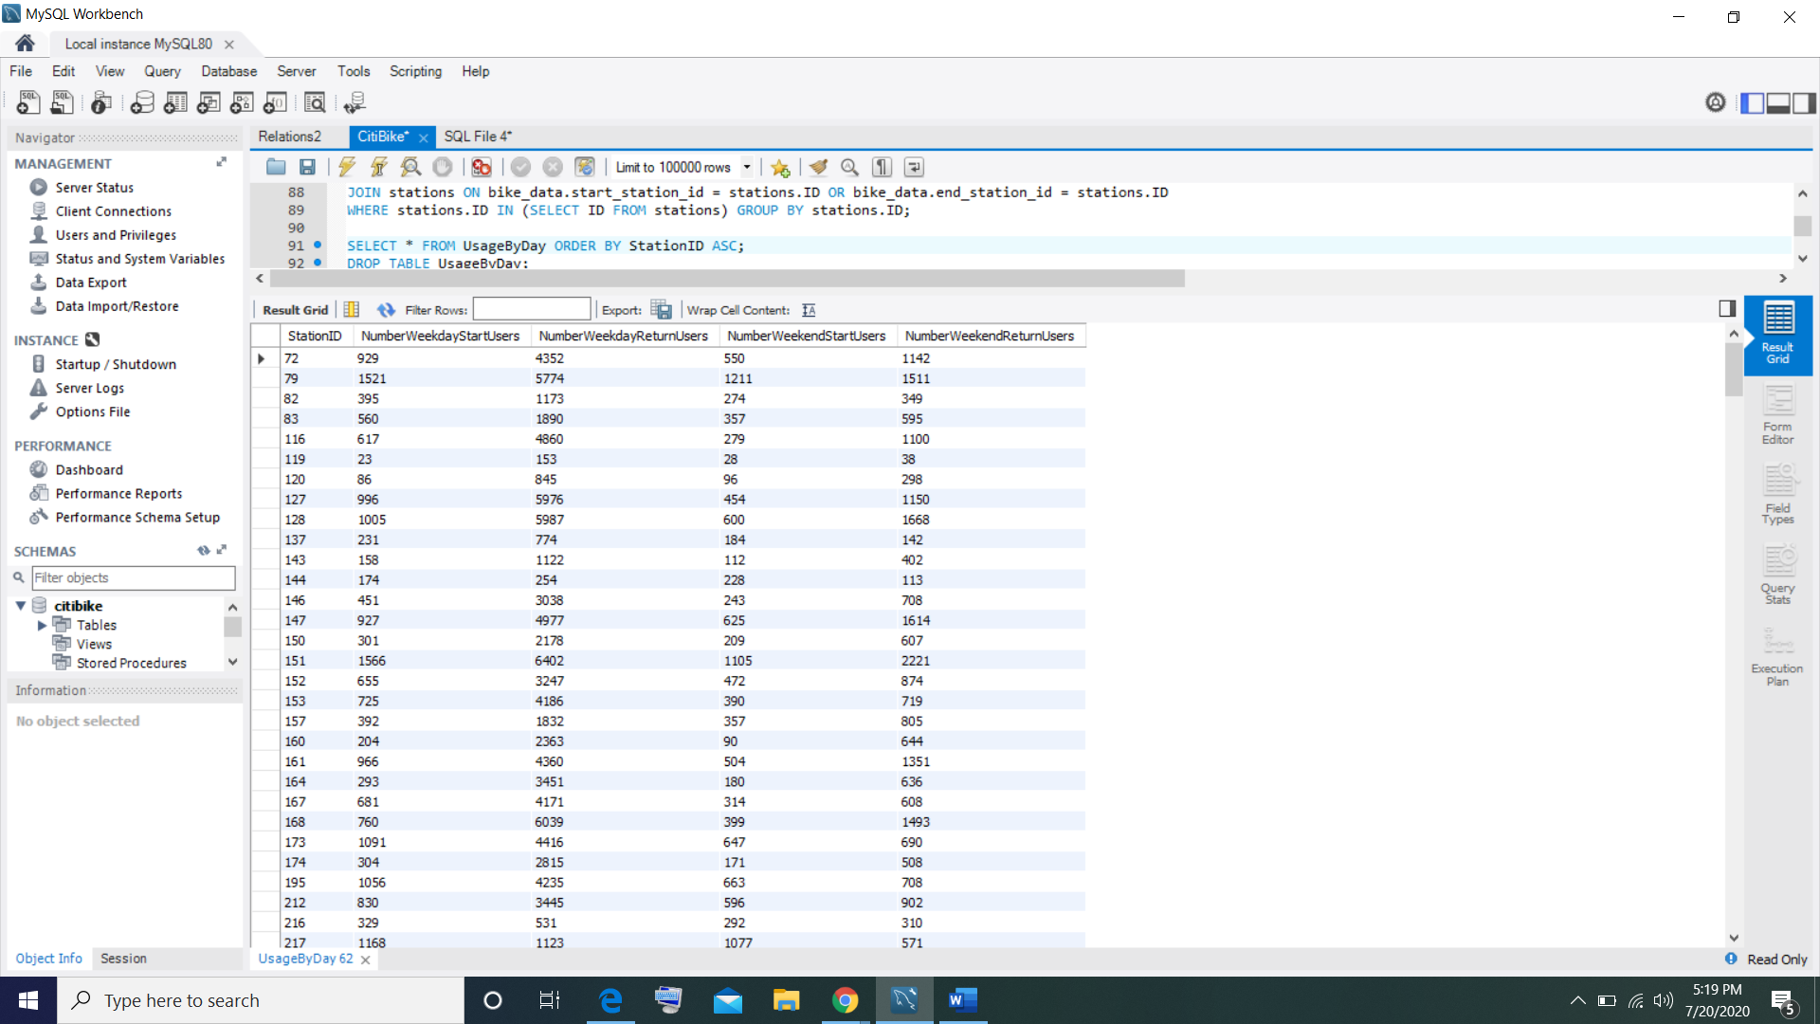

**Table – UsageByGender**

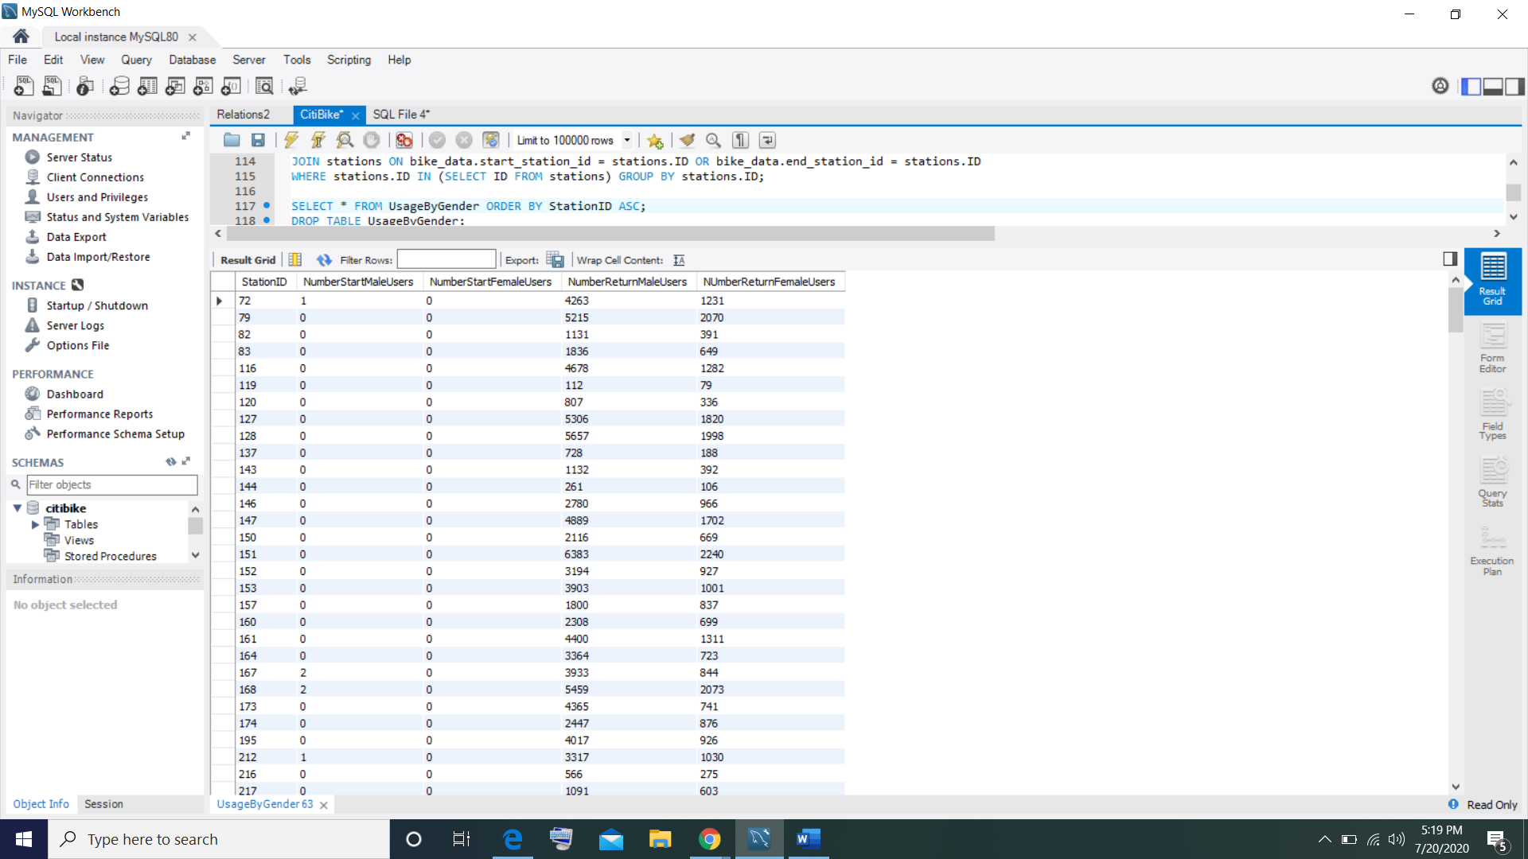

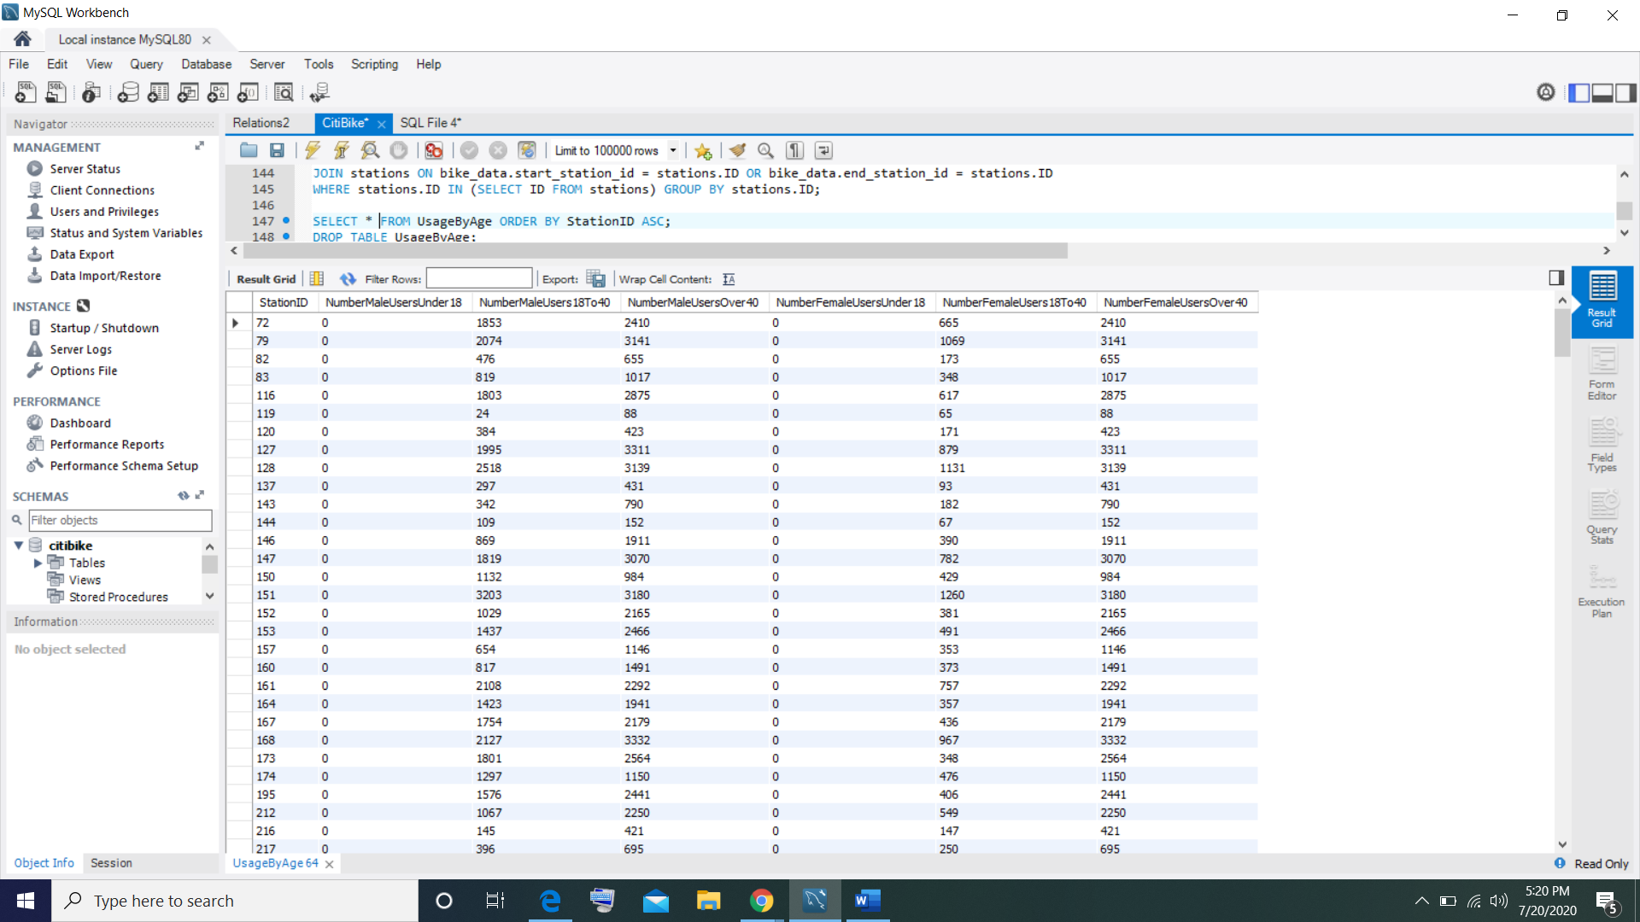**Table – UsageByAge**

**Table – FrequentTrips**

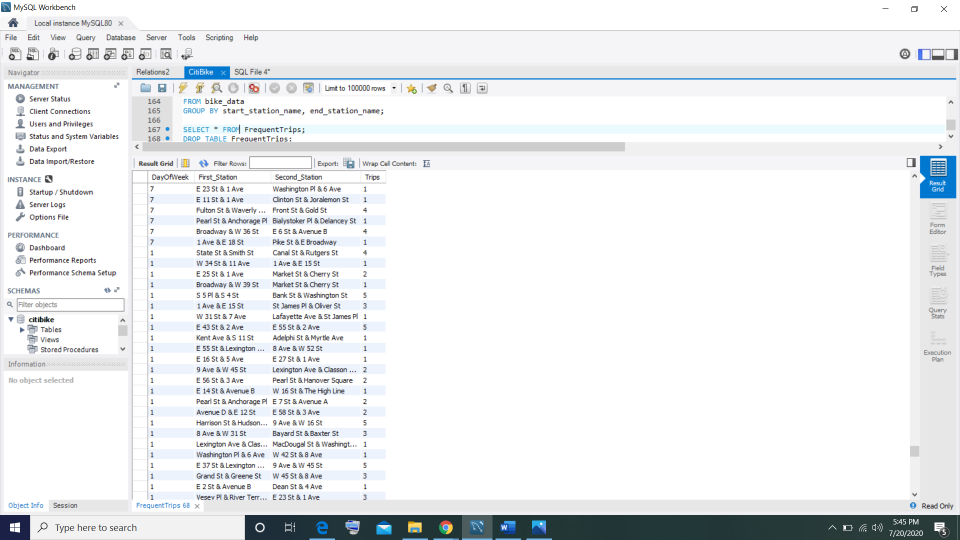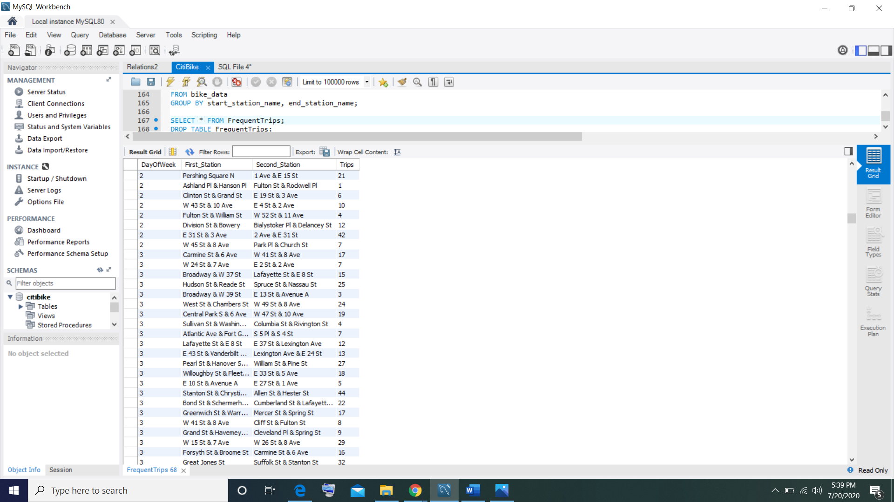

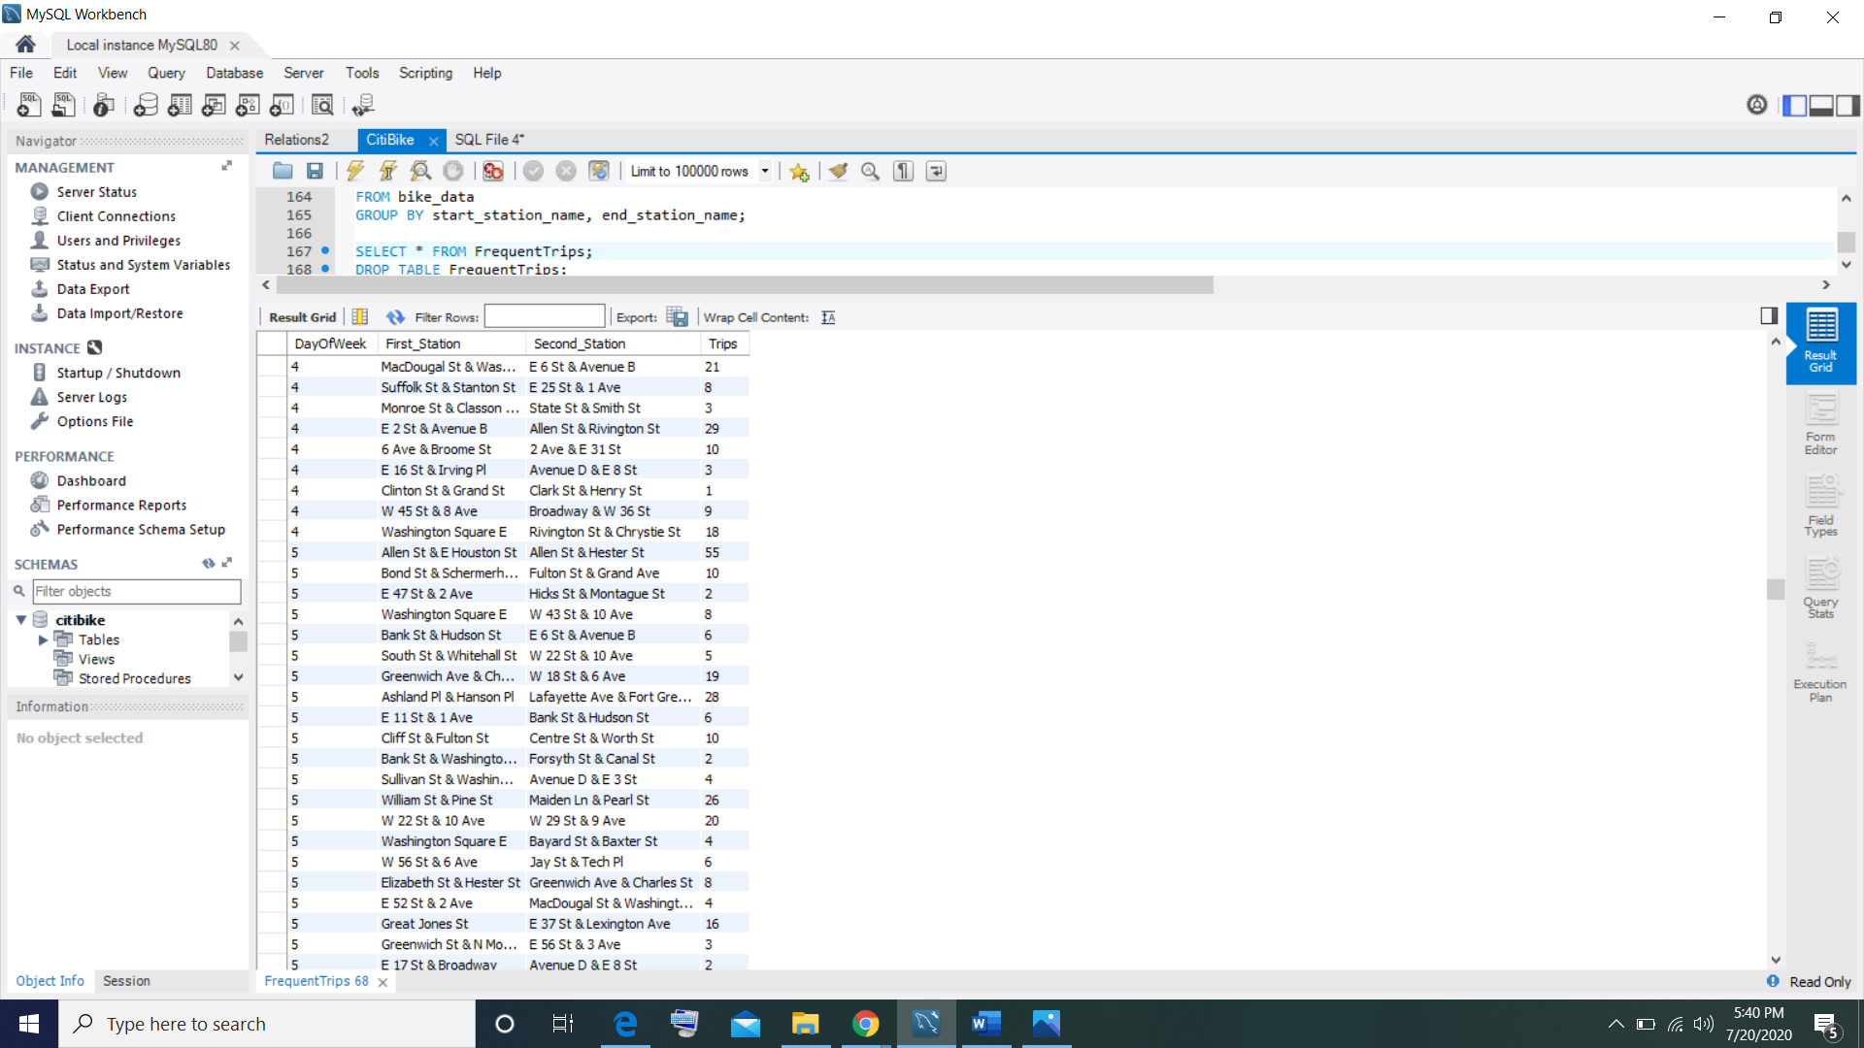

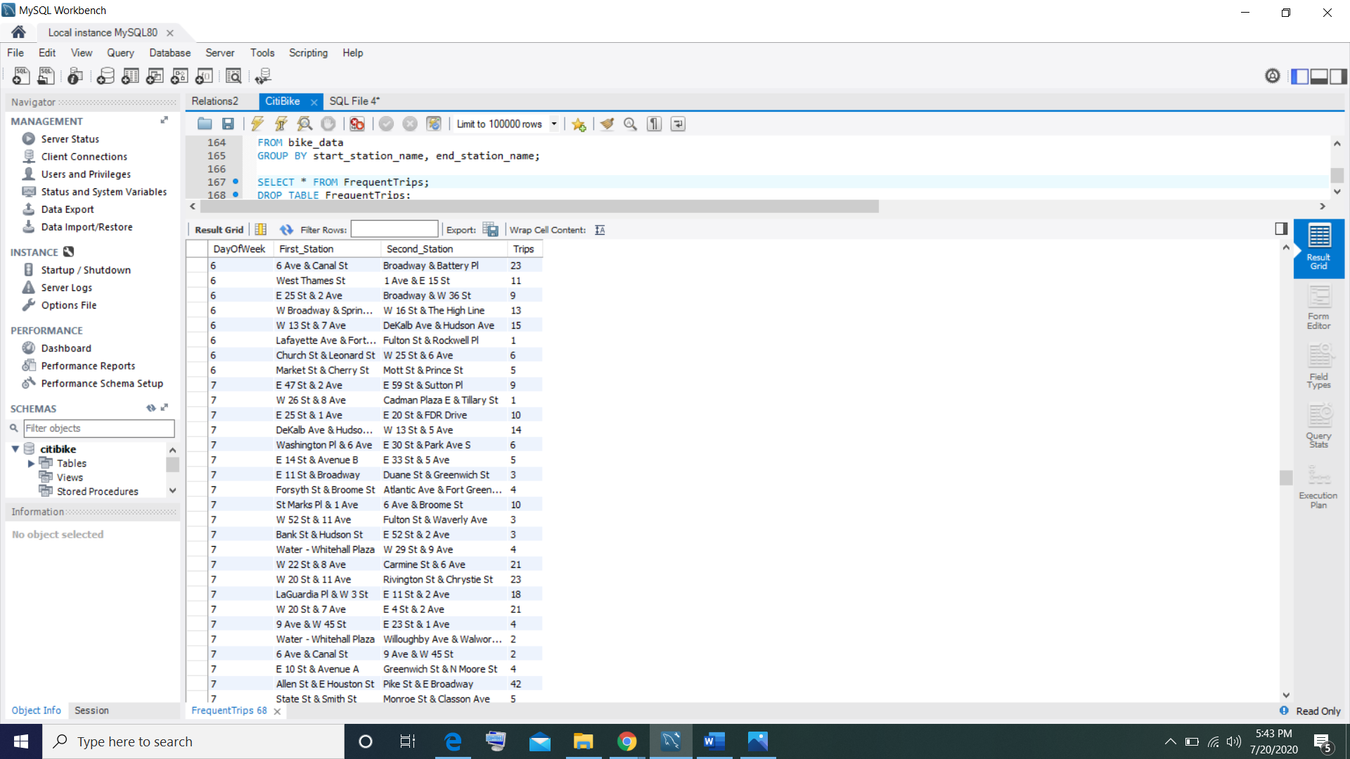

**Table – Vacant Stations**

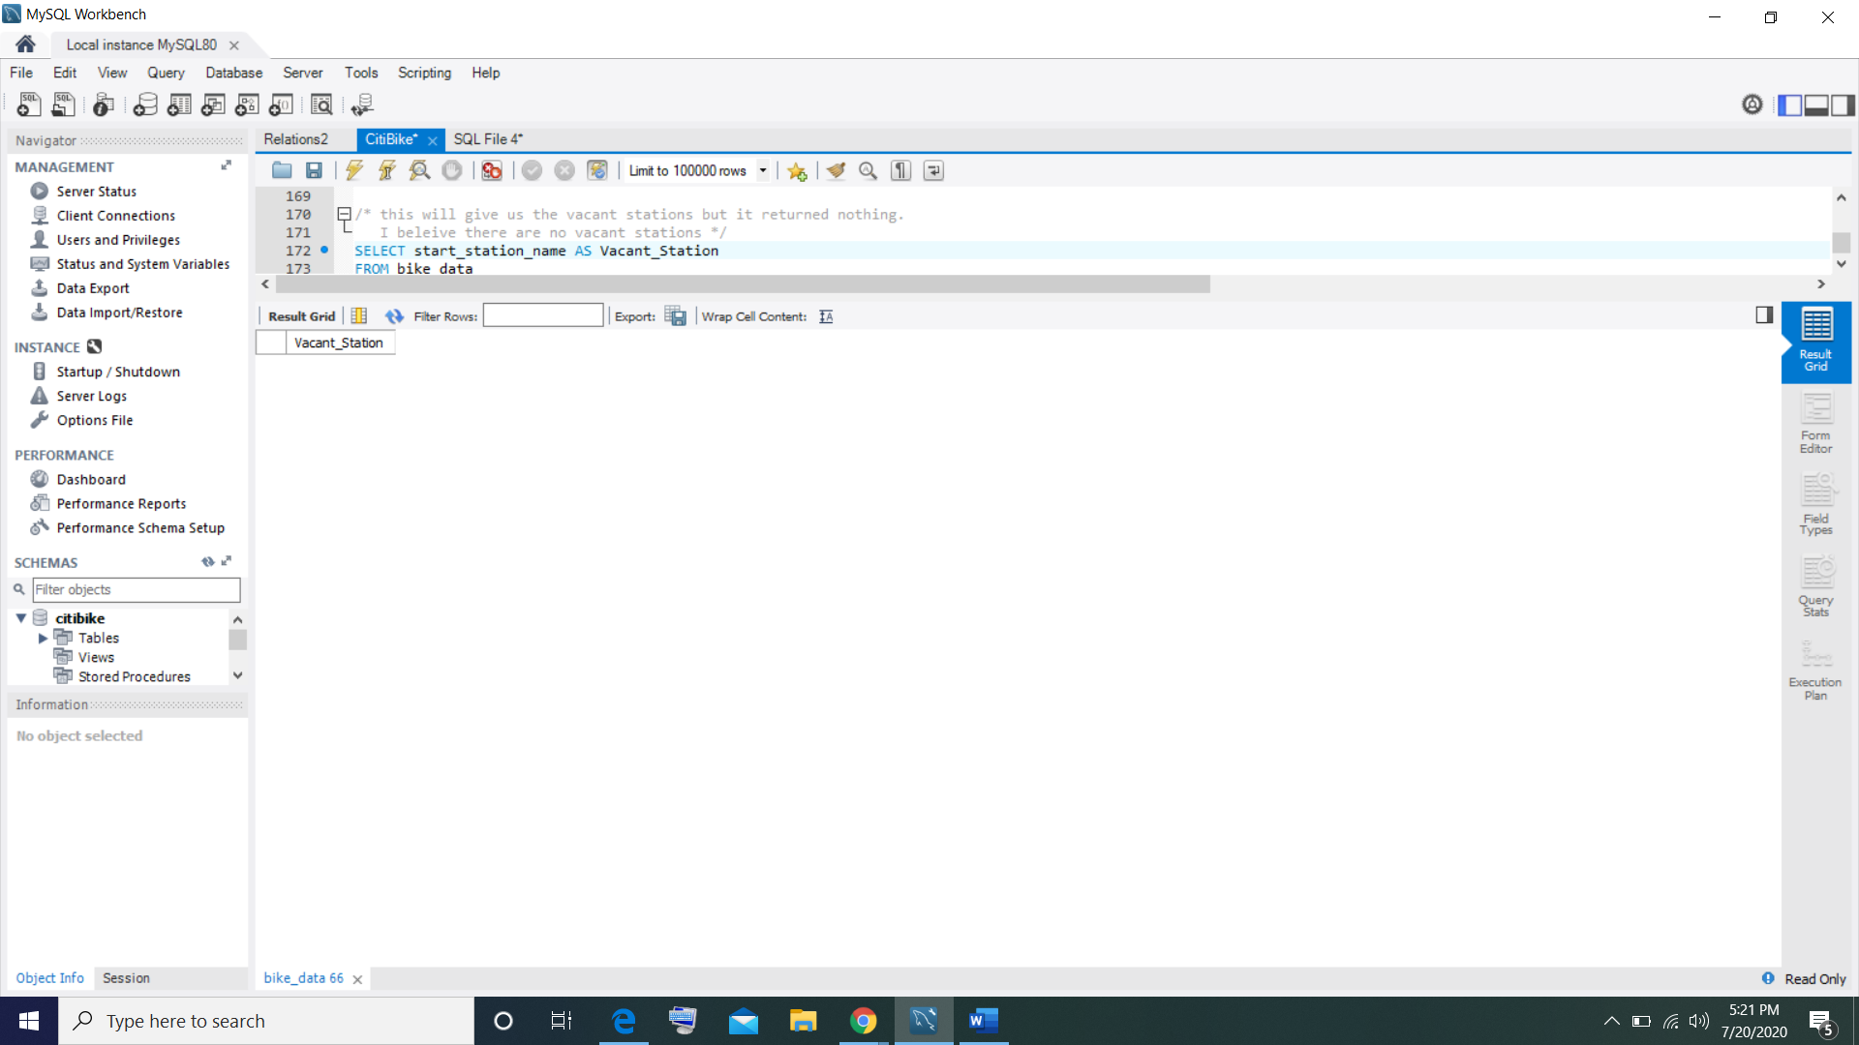I did not find any vacant station within my query I have tried others as well. I am concluding that there are no vacant stations within this database of CitiBike stations.